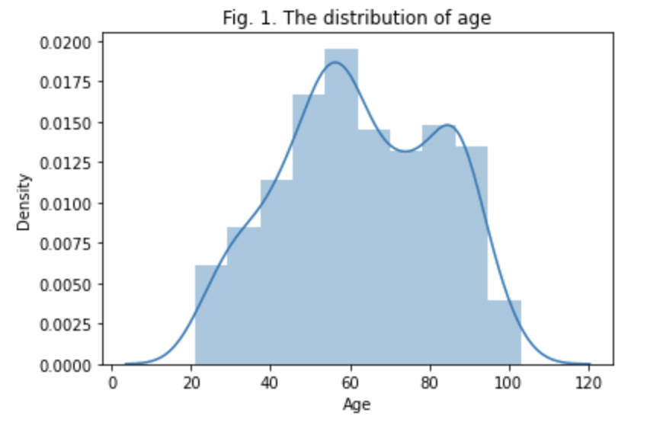

As is shown in Fig. 1, the distribution of age is a little similar to the bell curve, but with twin peaks (in the 55-60 and the 80-85).

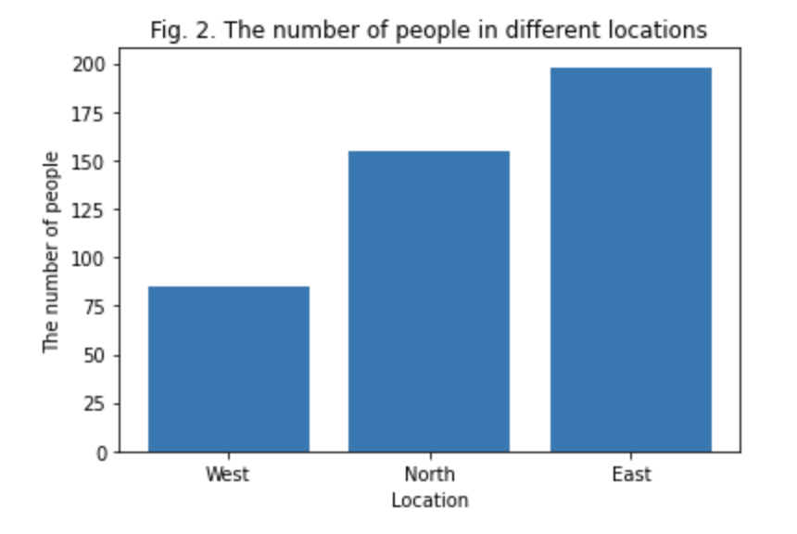

From Fig. 2, it can be seen that there are more users in East than that in West or North.

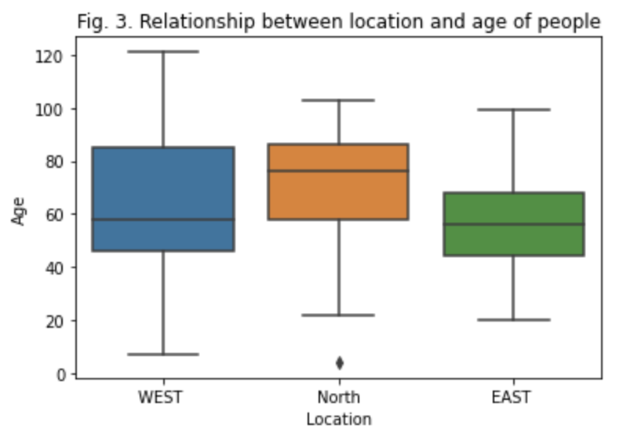

As is shown in Fig. 3, the users in North are order. And I found an outlier in North.

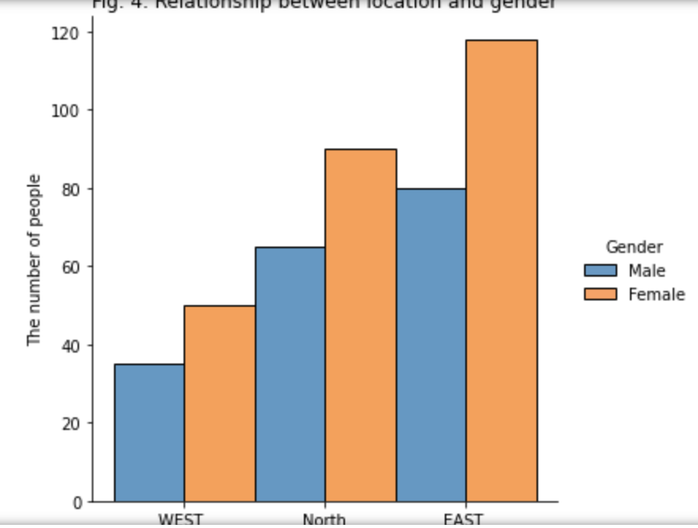

From Fig. 4, it is obvious that the number of female is greater than that of male in three regions. And the numbers of men and women are increasing in the West, north and East.

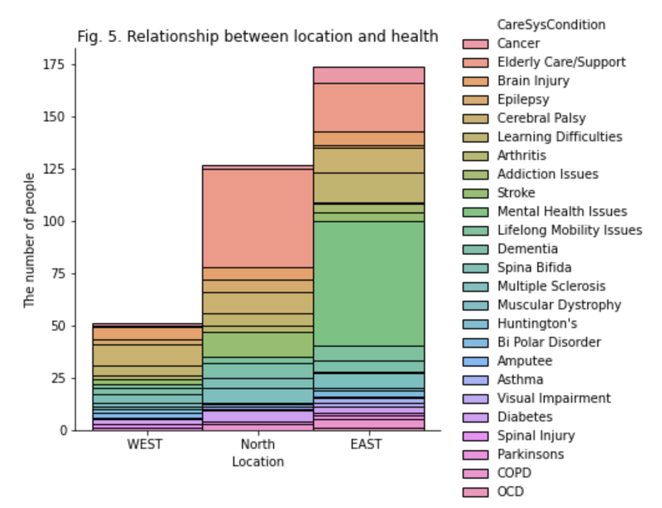

As is shown in Fig. 5, In gerneal, the east had the highest number of users with illness, followed by the north and the west. In specific, the people with cerebral Palsy are most in West. The people with elderly care/support are most in North. The people with mental health issues are most in East.

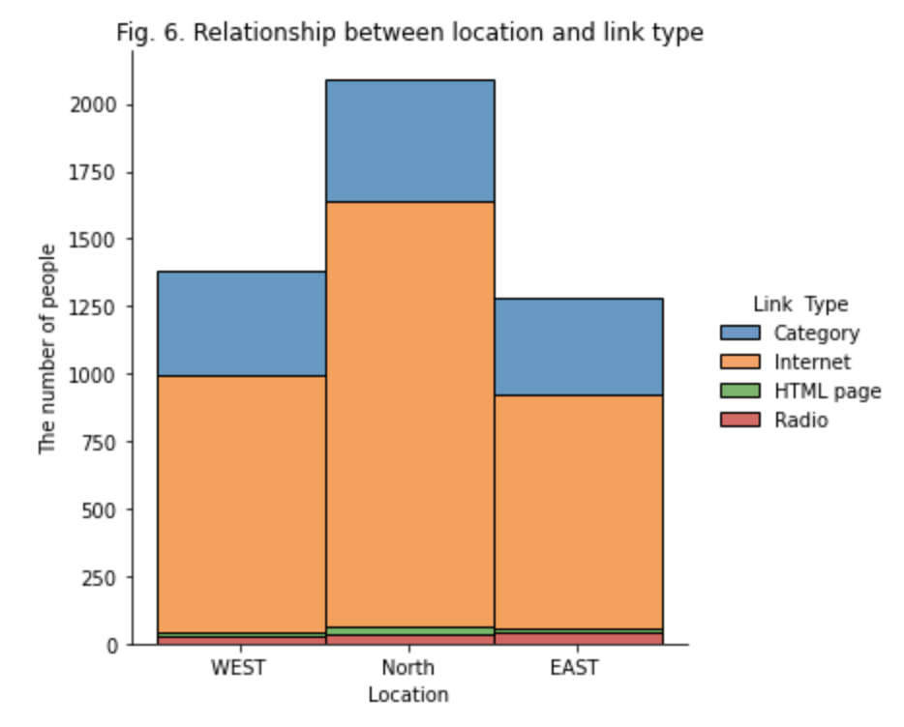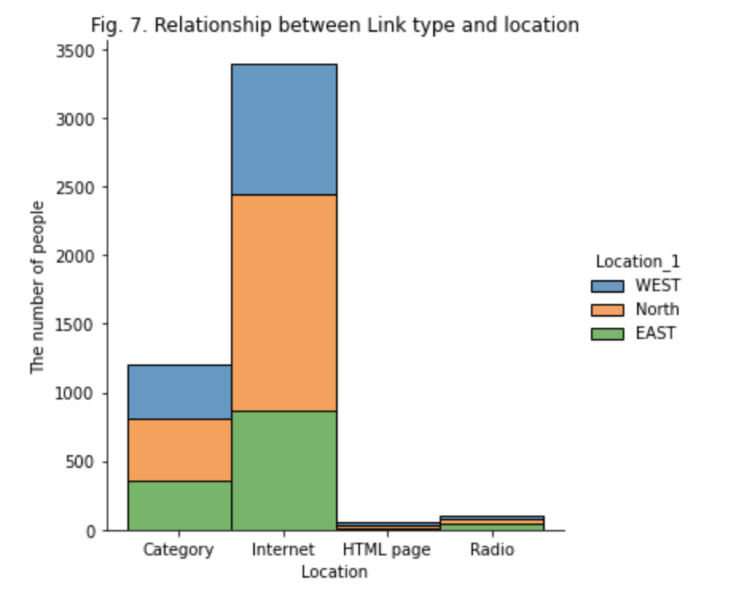

According to Fig.6 and Fig.7, it can be seen that "category" and "Internet" are the most popular types of entertainment activities conducted by users in the eastern, western and northern regions. And more specifically, "Internet" is a much larger type than "category". But in terms of the number of people, users in the north have the highest number of entertainment activities.

Hypothesis 1: Men are harder to become users of the company than women. It can be seen from Fig. 2 that there are fewer male users than female users in all three locations. For testing the hypothesis, I think it is possible to enrich the data and validate it by interviewing male and female users, or by consulting the data owner.

Hypothesis 2: Middle-aged women in East area may face more psychological stress. The reasons for my assumption are based on the results of Figs. 3, 4 and 5. Fig. 3 shows that users in East area are relatively young, are the middle-aged and elderly groups. Fig. 4 shows that the proportion of female in all three areas is higher than that of male in terms of gender composition. However, in Fig. 5, the number of people in East area are significantly higher in terms of psychological stress than in the other two areas, suggesting that the cause may be age-related. Thus, I speculate that middle-aged women may face greater psychological pressure, which is also related to the actual female menopause, post-retirement life. To test this hypothesis, I needed to analyze the age composition and sex ratio of people with mental health issues in East area, and compare three areas based on the two indicators.

Hypothesis 3: The main requirement for people who are 55-60 years old is mainly elderly care/support, and the main requirement for people who are 80-85 years old is solving mental health issues. As is shown in Fig. 1, there are two peaks in the users' distribution of age, one is 55-60, the other one is 80-85, and the number of the former is more than the latter. The hypothesis was proposed in view of the results of Fig. 3 and Fig. 5. To verify this hypothesis, the age composition of elderly care and mental health issues in Fig. 5 needs to be analyzed.